**Points to be considered by DDO’s while projecting demand of LOC for the month :**

1. Ensure closure of R&P of the previous month i.e before projecting demand for the current month i.e.**R&P account of previous month need to be closed**. The system will not accept any new demand without closure of last Month’s R&P Account.
2. Balances of Cash and Bank at the end of the month to maintained at barest minimum in commensurate with the objective of running day to day activities for the intervening period of next demand.
3. Demand can be projected **twice** in a month as per timelines defined below :

**Timelines**

**For April 2017 only Original demand:**  From **7th to 15th of the April 2017**

* **It should include** 
  + - Demand of **Salary** for the current month
    - Demand of **OAE** for next month
    - **Pre-requisite** : R&P of the previous month to be closed
* **DG’s AIR/DD (April)** : **16th to 20th**  of APRIL 2017 for processing / recommending of the demand.
* **PB Sectt. (April): 21st to 25th** of APRIL 2017 for approving /release of the demand

1. **Timelines MAY 2017 –Onwards**

**Original Demand (Mandatory- Even when zero demand)**

**a.. DDO’s : 7th to 15th of the month**

* + - Demand of **Salary** for the current month
    - Demand of **OAE** for next month
    - Pre-requisite **R&P** of the previous month to be closed
* **DG’s AIR/DD**: **16th to 20th**  of month for processing / recommending of the demand.
* **PB Sectt.: 21st to 25th** of month for approving /release of the demand

**Additional Demand ( Not mandatory- For additional requirements if any)**

* 1. **DDO’s : 1st to 5th of month** 
     + - 1. Demand for Additional Salary for current month
         2. Demand for Additional OAE for the Current month
         3. Operational only when demand for previous month was projected.
  2. **DG’s AIR/DD : 6th to 10th** of month for processing /recommending of the demand.
  3. **PB Sectt.**: **11th to 15th** of month for approving /release of the demand

1. **Important :**
   1. DEMAND TO BE PROJECTED IN THOUSANDS ONLY eg demand of Rs 112456/= to be shown as Rs 112000 only
   2. Status of the **previous demand** need to be ascertained before projecting the next demand through a report accessible to all DDO’s. (check status report from system)
2. DDO’s with dual charge of executing works for both AIR and DD have to project the demand separately for both the units. Form has been customized accordingly.

**Step Wise procedure for projecting demand by DDO’s**

* Log into application [**www.pbinfo.air.org/ems in**](http://www.pbinfo.air.org/ems%20in) as usual with your login id manager and password specifically known to you.
* Two new options have been added to menu options as shown in Fig-1 .

1.**Projection of LOC for Current Month**

2. **Current Status of LOC demand**

* Click on the option **Projection of LOC for Current Month** .Access mechanism similar to posting transactions for compiling R&P System. Demand to be raised by Asst first with his login in and subsequently to be finalised by DDO.

**FIG-1**

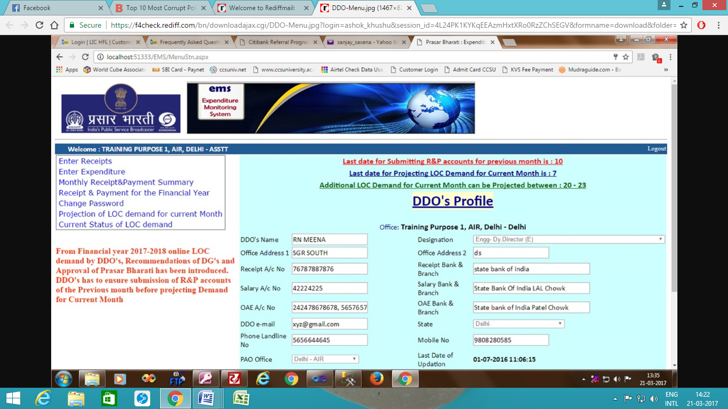

**Click here to find out the status of the demand**

**Click here to project demand of LOC on basis of Pending Claims to paid in the current month**

* By Clicking on menu option “**Projection of LOC for Current Month”** a new screen of selecting month , year and financial year will be displayed as shown in **Fig-2.** Care need to be exercised for selecting correct Current Month , Current Year and Current Financial Year.

Fig-2

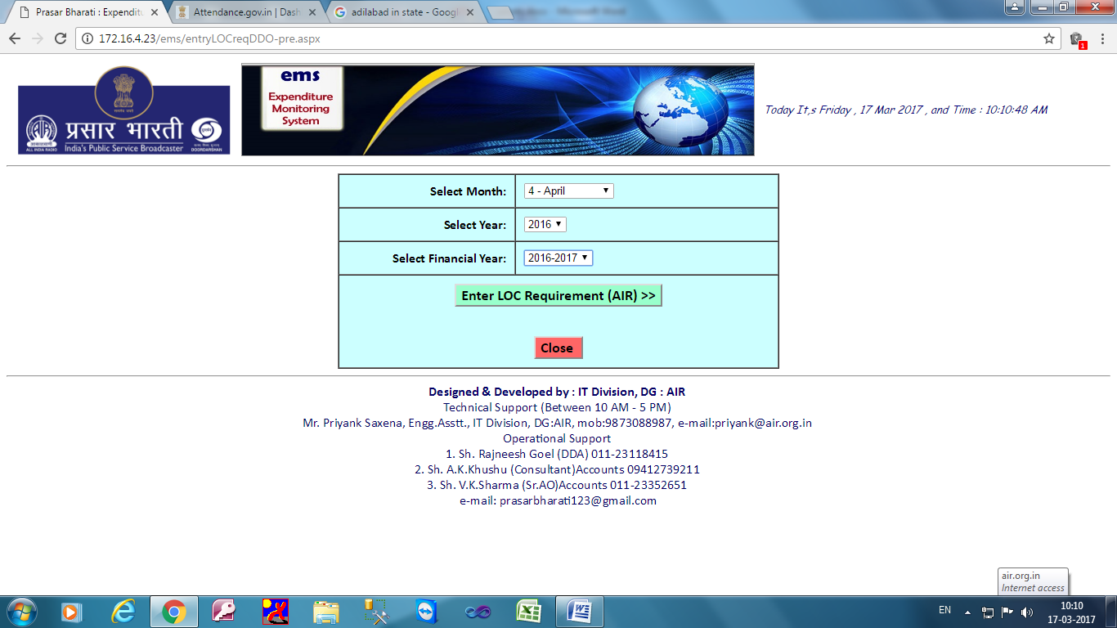

**Clicking here will redirect to a dialog box as shown in Fig-3**

**Select current month , year and the Financial Year**

* Clicking on the button “**Enter LOC requirement** “ after selecting the month , year and the financial year a new dialog box gets loaded on the screen for projecting the demand of the month as shown in **Fig -3**
* Before entering the data kindly understand the elements of the dialog box – detailed procedure is explained in table below the dialog box.
* Also status of the previous demand may be viewed before raising new demand –explained later on in the manual.
* **Fig - 3 (Projecting Demand for the month )**

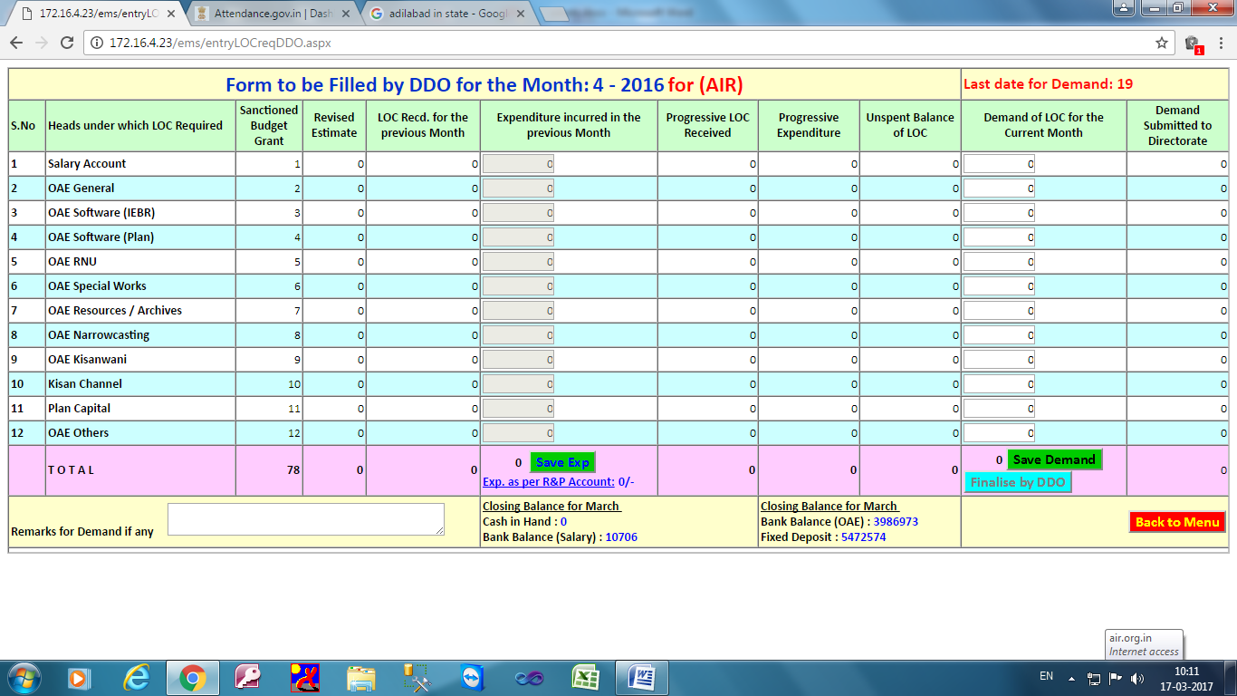

**Understanding elements of Form for Projecting Demand by DDO’s**

|  |  |  |  |
| --- | --- | --- | --- |
| **Slno** | **Particulars of item** | **Action by DDO** | **Status** |
| 1 | **Sanctioned Budget Grant** | No Action –Field Un-editable | Shows the SBG allocated by DG.- Demand of the month to be restricted to proportionate SBG so allotted . |
| 2. | **Revised Estimate** | No Action –Field Un-editable | Shows the RE allocated by DG- Demand of the month to be restricted to proportionate RE so allotted . |
| 3. | **LOC received for previous month** | No Action –Field Un-editable | System generated –Legacy data of the last month |
| 4. | **Expenditure incurred during the previous month** | With ASST login – Enter actual expenditure incurred in the last month within these 12 heads. Data can be saved only when the totals match with system generated totals besides item “**Exp as per R&P Account** “ displayed in last row of totals “ | Both **“ Save Exp.** “ and “**Save Demand** “ Buttons gets enabled after the reconciliation of two sets of figures Clicking on the **“ Save Exp.** “ button ASST can save the details of expenditure entered. |
| 5. | **Progressive LOC received** | No Action –Field Un-editable | System generated –Legacy data of the last month –Shows progressive LOC received till date |
| 6. | **Progressive Expenditure** | No Action –Field Un-editable | System generated –Legacy data of the last month- Shows progressive Expenditure incurred till date |
| 7. | **Unspent Balance of LOC** | No Action –Field Un-editable | System generated –Legacy data of the last month. Shows LOC in hand under the specific head. |
| 8. | **Demand of LOC for the Current Month** | With Asst Login demand of LOC may be projected strictly restricting to the expenditure to be incurred during the month. | Demand to be raised for the heads for which SBG /RE has been allocated by DG’s office. By clicking on “**Save Demand** “ button all the requirements of LOC for the month will be saved by Asst. |

NOTE: DEMAND FORM WILL BE SAME FOR BOTH ASST AND DDO OF THE STATION . THE DIFFERENCE LIES IS IN FINALISAION OF THE DEMAND- POWER VESTED WITHH DDO ONLY. BUTTON “**Finalise by DDO**” ENABLED FOR DDO ONLY

**Procedure for Checking Status of previous demand**

* By clicking on the menu option “**Current Status of LOC demand “**  a dialog box on the screen will be displayed to show the current status of the demand previously projected as shown in Fig-4
* Processing indicators
  + **In process** – means that the demand has not been recommended or approved as the case be by the competent authority
  + **Processed** – Amount under the relevant column will be displayed.

**NOT APPROVED BY PB TILL DATE**

**DEMAND PROJECTED BY DDO**

**AMT. RECOMMENDED BY DG**

**Fig-4**

